**USING RAPTOR – CALCULATE FIBONACCI SERIES**

**FLOWCHART**

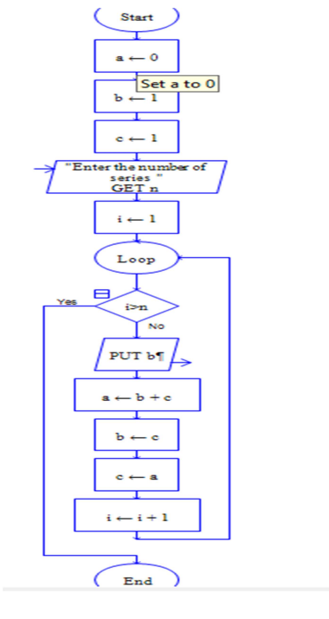

**OUTPUT**

INPUT IS 9

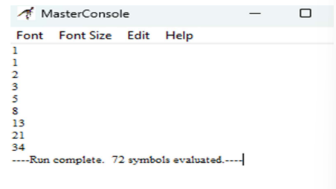

**RESULT:**

The program is executed and verified successfully